American University of Sharjah  School of Engineering  Department of Computer Engineering  P. O. Box 26666  Sharjah, UAE |  | Instructor: Imran A. Zualkernan  Office: EB1-260  Phone: 971-6-515 2953  Fax: 971-6-515 2979  e-mail: izualkernan@aus.edu  Semester: Spring 2016

COE 494 Internet Computing
Homework Assignment #4
Q1 (10 points).

Modify the System implemented in Homework Assignment #3, so that it uses Onsen UI and Cordova for implementation. The backend should be CouchDB.

Deliverables:

1. Design document showing how the various pieces of the program have been constructed including an explanation of the various routes, conversion from GIFT to JSON and back etc. In addition, the document should contain screen shots showing the complete functionality of the program.

2. A Zip file containing gittable code for the complete application. The folder should also include a readme file showing how to install and configure CouchDB etc.

Homework Guidelines:
Homework is due at 5:00 p.m. on due date. Late homework assignments will not be accepted. YOU MUST UPLOAD ALL CLASSES IN ONE WORD FILE ON ILEARN AS WELL.
The homework assignments need to conform to the following guidelines:
- Use A4 white paper for all you work. Use one side of the paper only.
- All drawings should be neat and clean. Rough sketches are not acceptable.
- All writing should be readable. Underline or box all answers.
- Each homework assignment should have the cover sheet provided in the network folder that includes your assignment due date on the left, your name in the center, class number (i.e., COE 210) on the right, and page number in the extreme right corner. The cover sheet should be followed by the homework assignment questions and then followed by your solutions.
For programming assignments, a hardcopy of the source code and any output should be submitted. Suitable comments should accompany your source code.
Policy on Collaboration and Cheating:

- The regulations governing Student Academic Integrity Code given in the Academic Regulation section of AUS catalog will be observed and strictly enforced.

- In case of cheating, assistance in cheating or plagiarism of any kind whether in homework assignment, project assignment, laboratory assignment, quiz or examination will result in an "F" grade for part or all of the above.

- Presenting another person's work as your own constitutes cheating, whether that person is a friend or an unknown student in this class or a previous semester's class. Everything you turn in must be your own doing, and it is your responsibility to prove it to me that it really is your own work, whenever the question arises.

- Giving a solution or partial solution to another student, even with the understanding that it will not be copied is another form of cheating.

- You are encouraged to help each other learn the course material by discussing the work before you do the homework and/or lab assignments. Students are expected to be capable of distinguishing between helping other students and cheating. For example, explaining the meaning of a question is an example of interaction that is encouraged. However, working together to develop a single solution and then turning in copies (or modified versions) of that solution under multiple names is considered cheating.

- Each student is expected to submit his/her own work. Group homework’s will be penalized by dividing the points between the perpetrators. No if’s and but’s. Guard your work. If somebody cheats from you, you are as guilty as the other person for letting this happens. Same goes for the exams.

The returned JSON from couchDB:
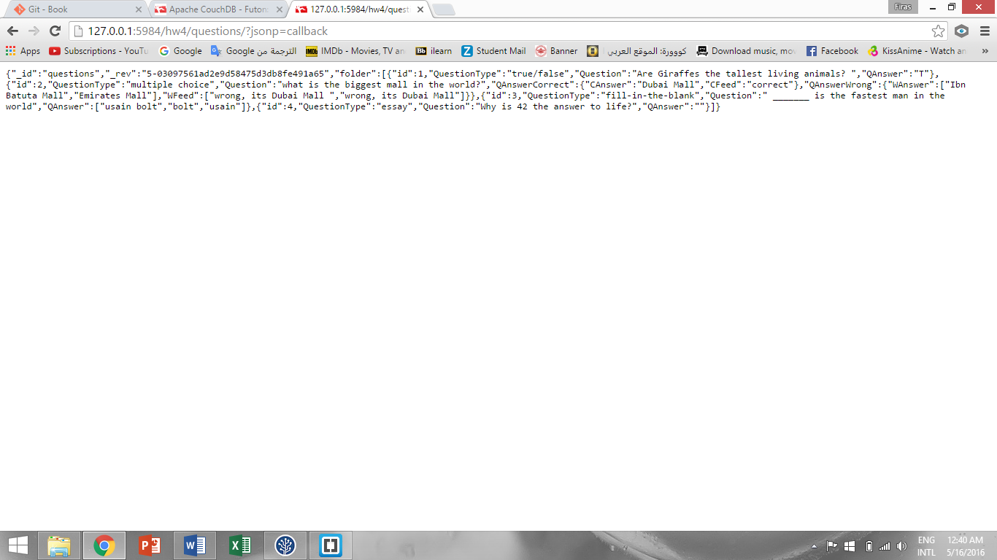

Screenshots:
